- Insert Data

- CREATE TABLE cats (
- name VARCHAR(50),
- age INT
- );
Insert a cat:
- INSERT INTO cats (name, age)
- VALUES ('Blue Steele', 5);
And another:
- INSERT INTO cats (name, age)
- VALUES ('Jenkins', 7);
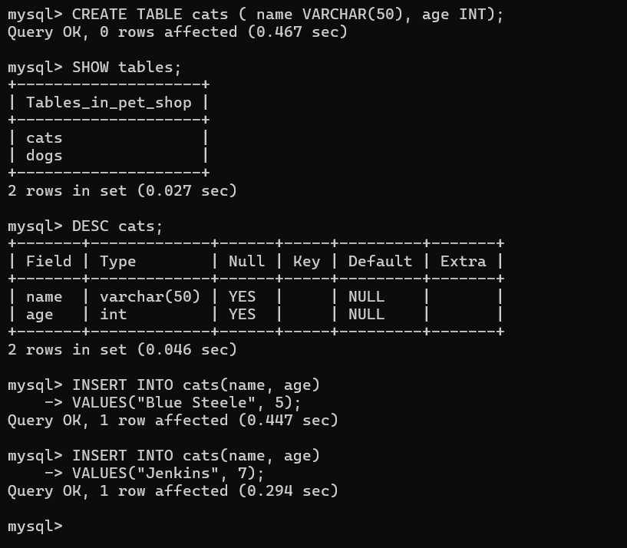

- Select Command

SELECT * FROM Tablename;

SELECT * FROM cats;

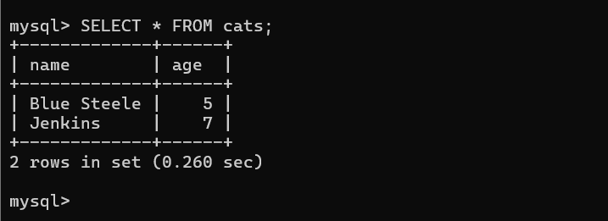

- Multi Insert

-- Single insert (switching order of name and age)
- INSERT INTO cats (age, name)
- VALUES
- (2, 'Beth');
-- Multiple Insert:
- INSERT INTO cats (name, age)
- VALUES
- ('Meatball', 5),
- ('Turkey', 1),
- ('Potato Face', 15);

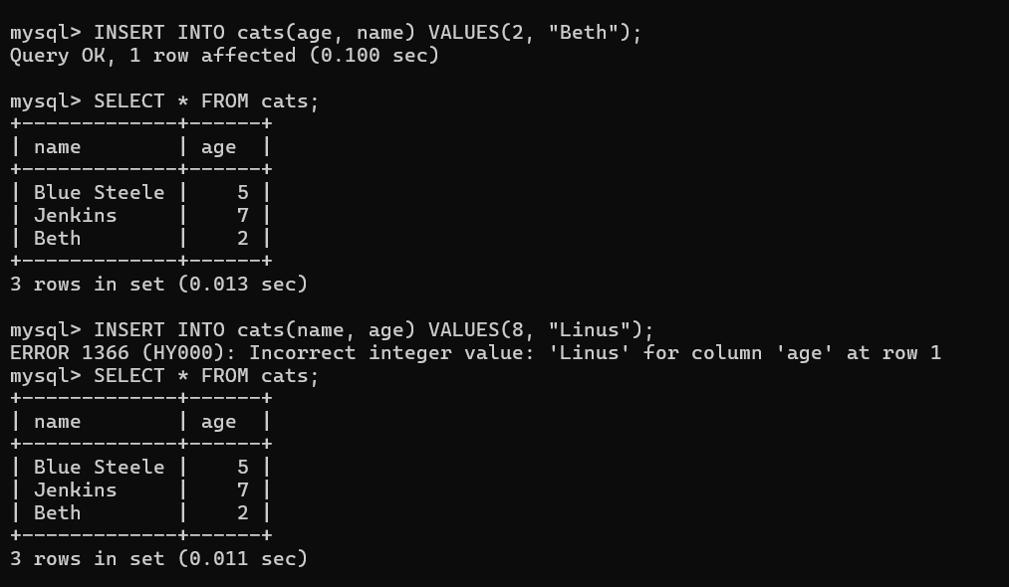

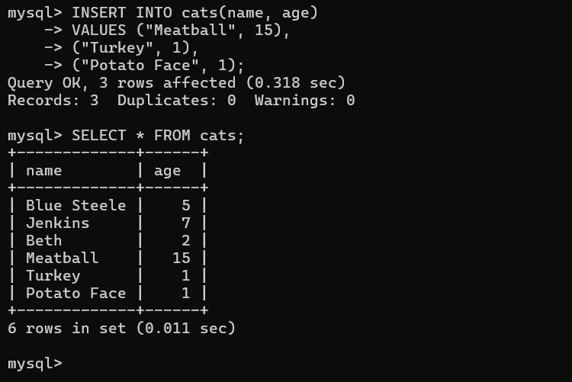
- Insert Exercise

INSERT Challenge Solution Code
- CREATE TABLE people
- (
- first_name VARCHAR(20),
- last_name VARCHAR(20),
- age INT
- );
- INSERT INTO people(first_name, last_name, age)
- VALUES ('Tina', 'Belcher', 13);
- INSERT INTO people(age, last_name, first_name)
- VALUES (42, 'Belcher', 'Bob');
- INSERT INTO people(first_name, last_name, age)
- VALUES
- ('Linda', 'Belcher', 45),
- ('Phillip', 'Frond', 38),
- ('Calvin', 'Fischoeder', 70);

DROP TABLE people;
SELECT * FROM people;
SHOW TABLES;

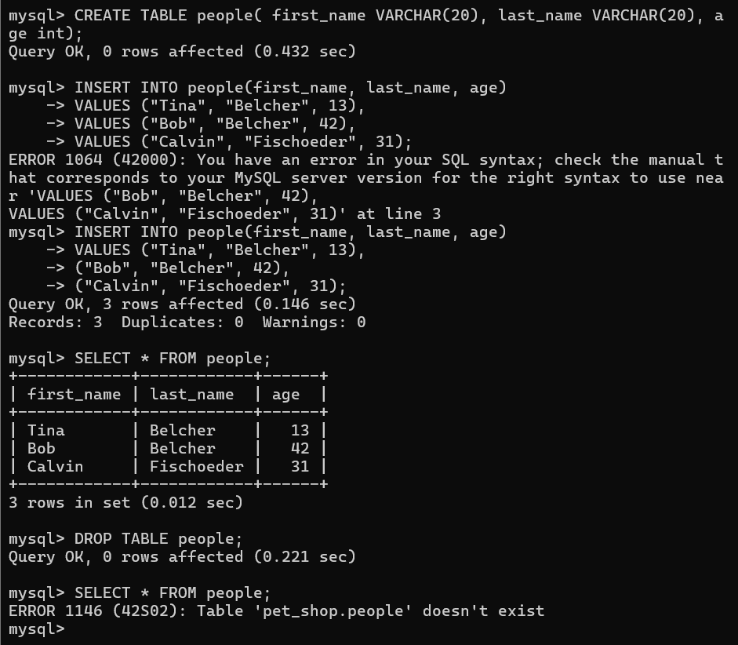

- Working With NOT NULL

Declares the NOT NULL Cmd in column user should enter the field otherwise raise an error.

- CREATE TABLE cats2 (
- name VARCHAR(100) NOT NULL,
- age INT NOT NULL
- );
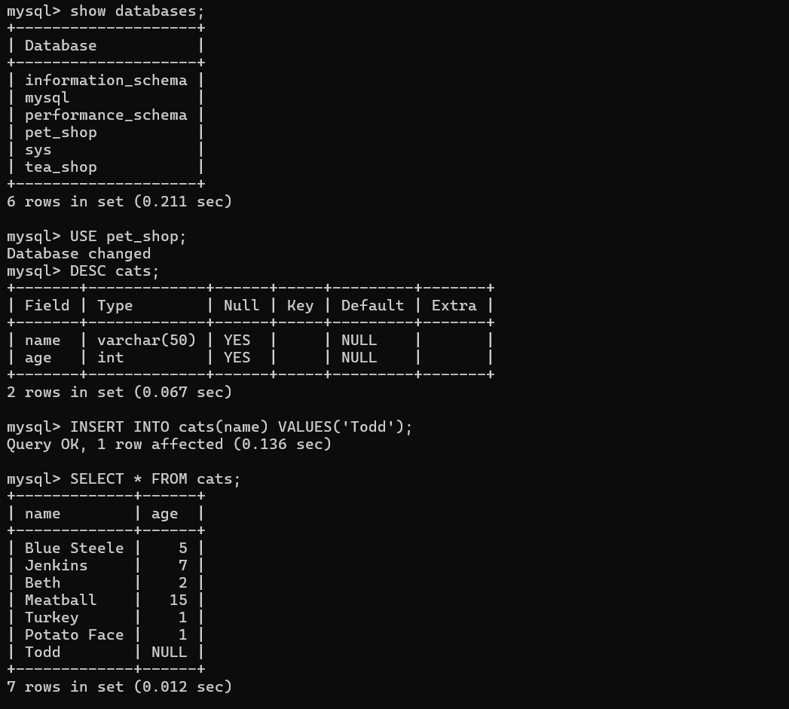

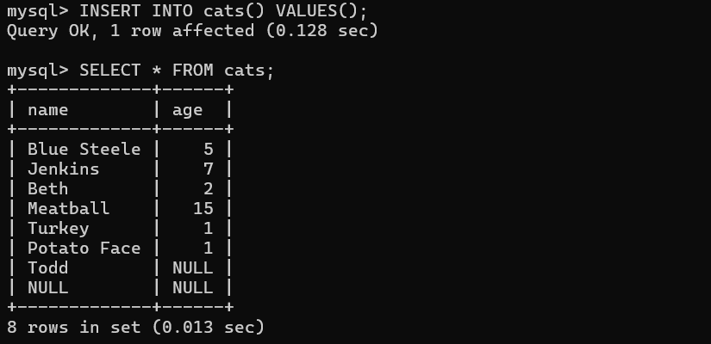

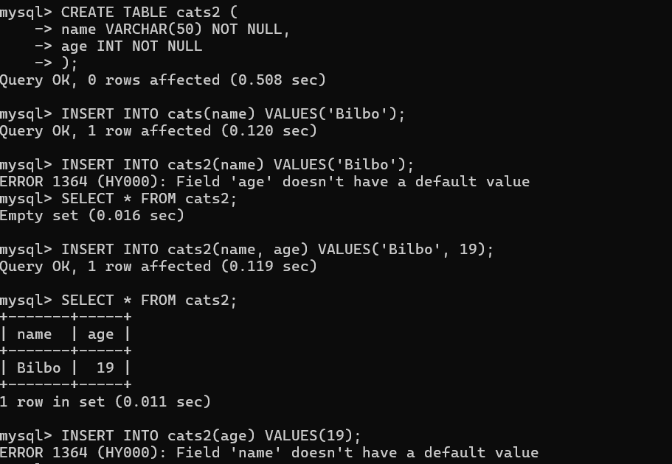

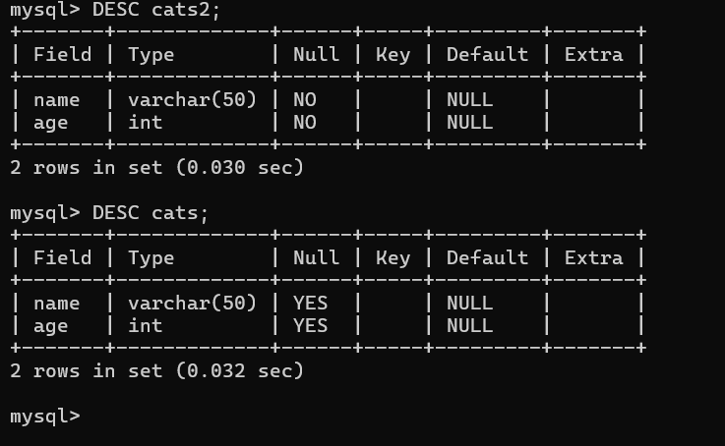

- Use Quotes in a VARCHAR.

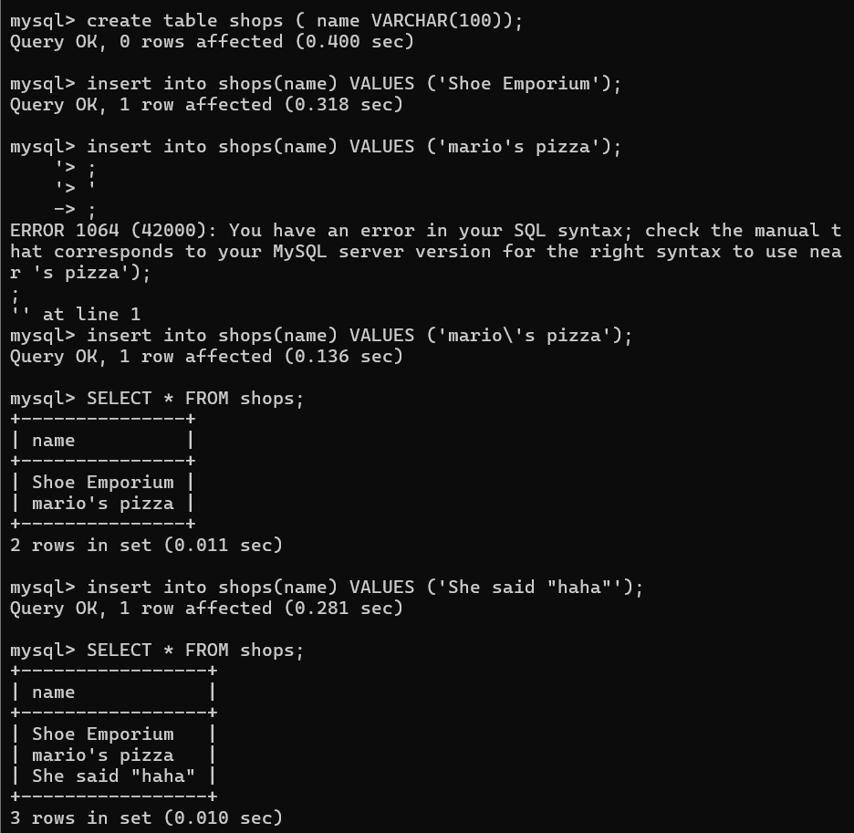

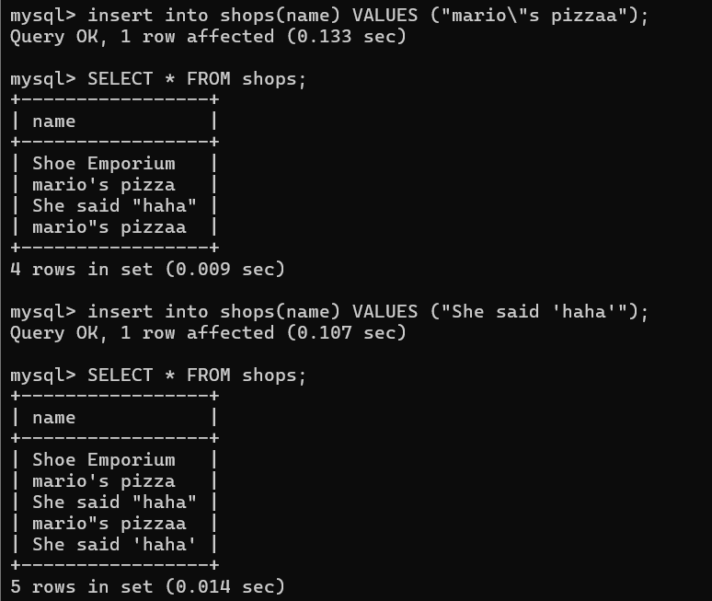

- Default Values
Users does not enter the one field then default value is added in the column.

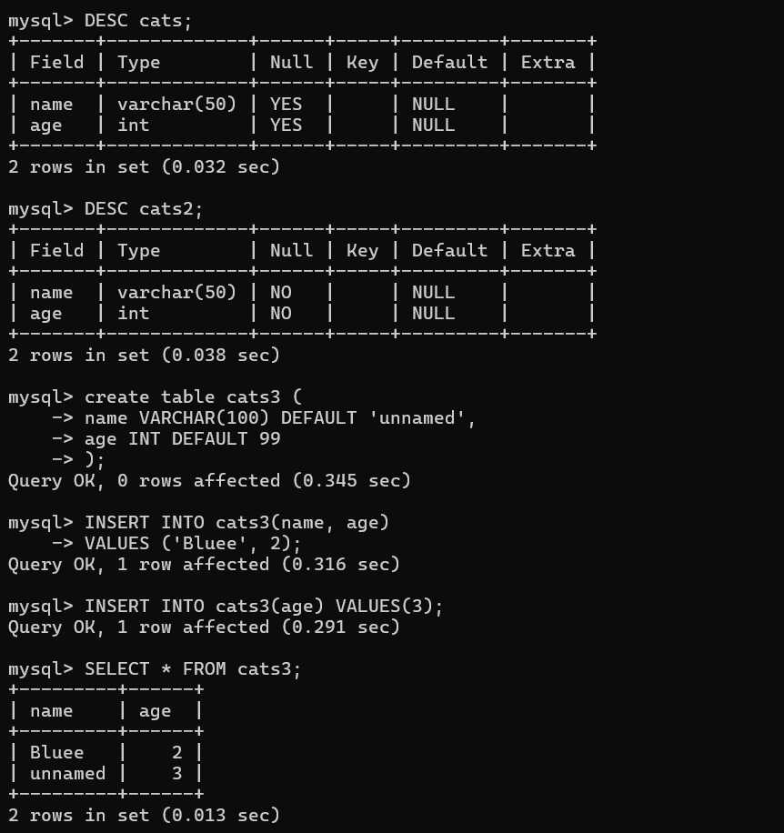

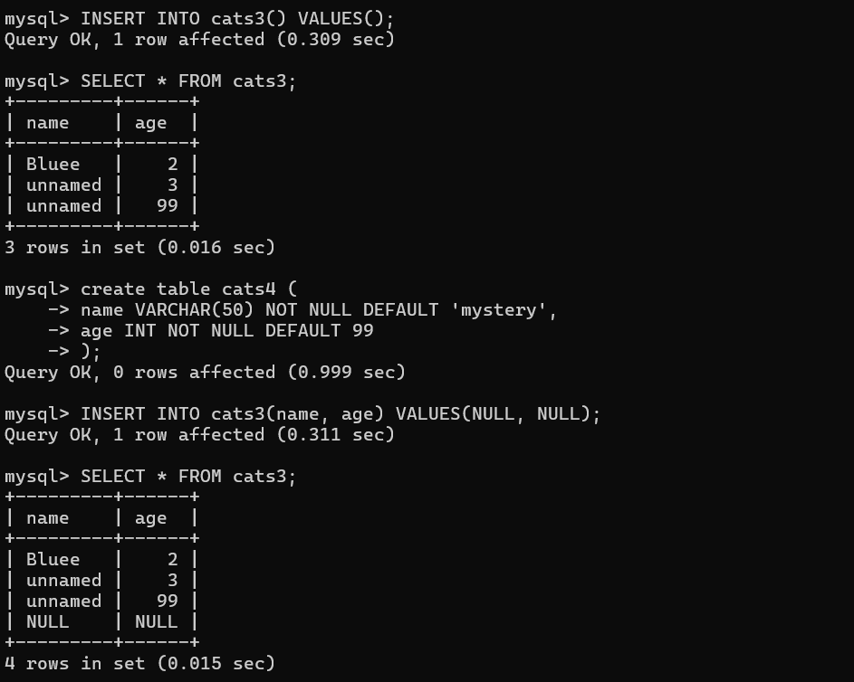

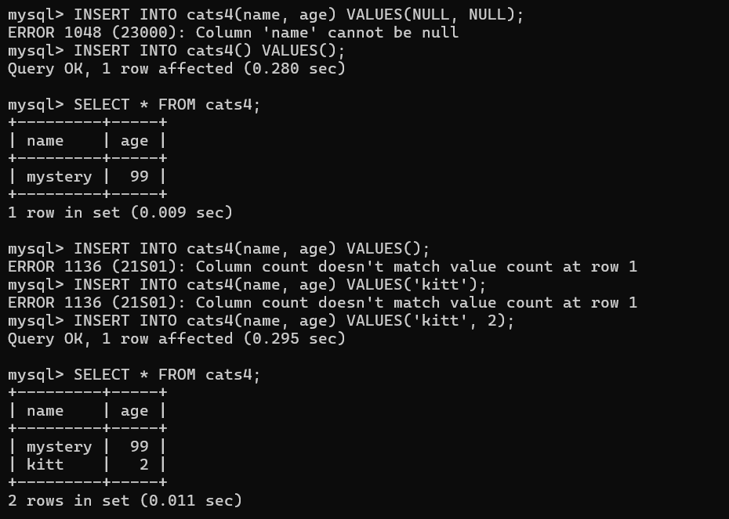

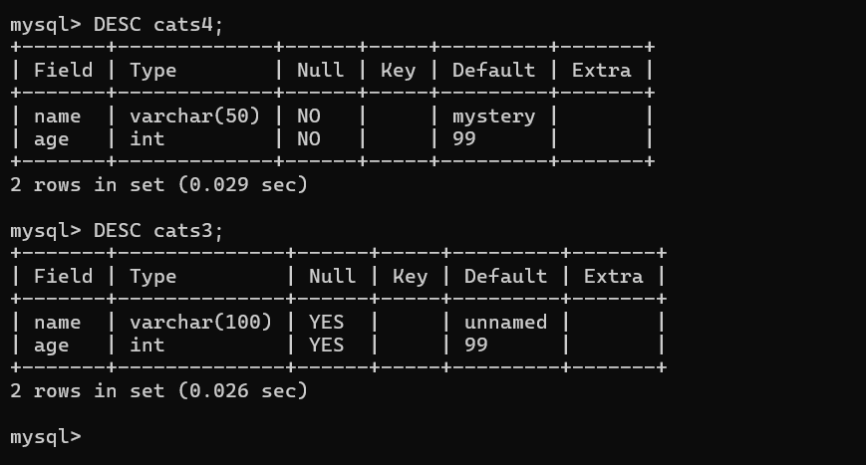

- Primary Key

Primary Key in MySQL is used for table column has a unique number and not repeat the same number.

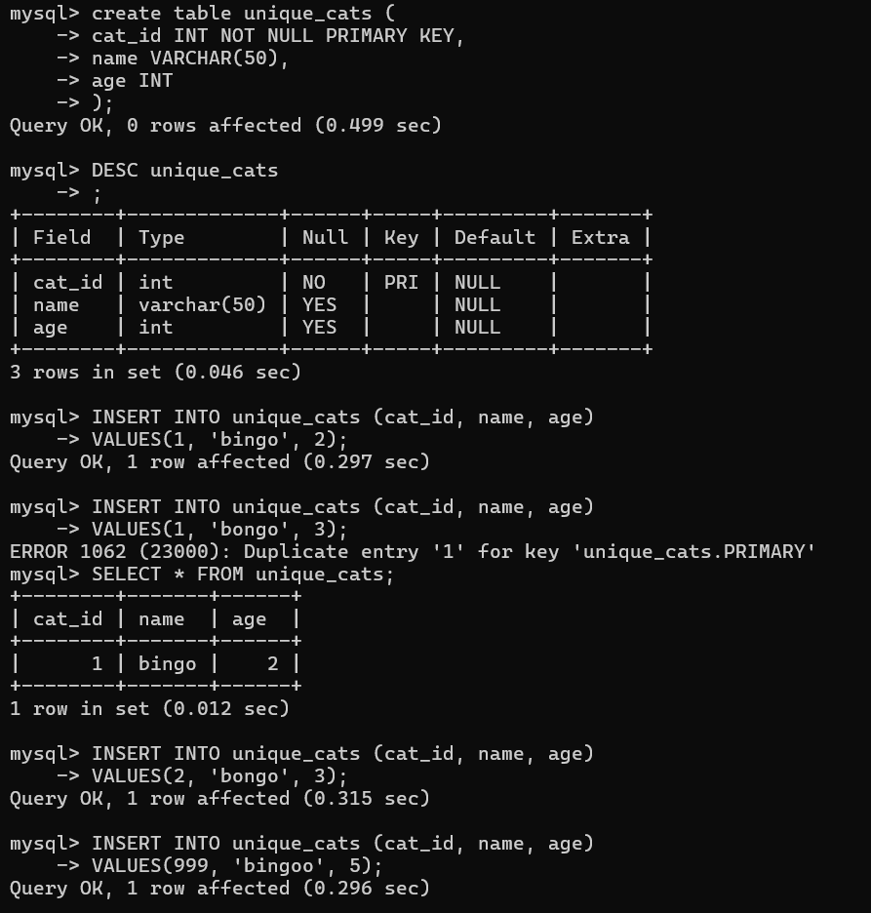

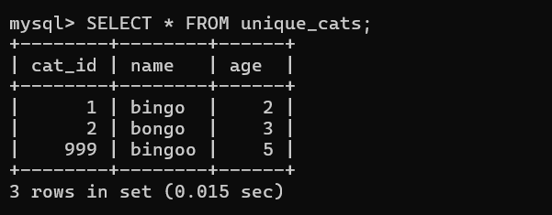

Another way to Declare PK.

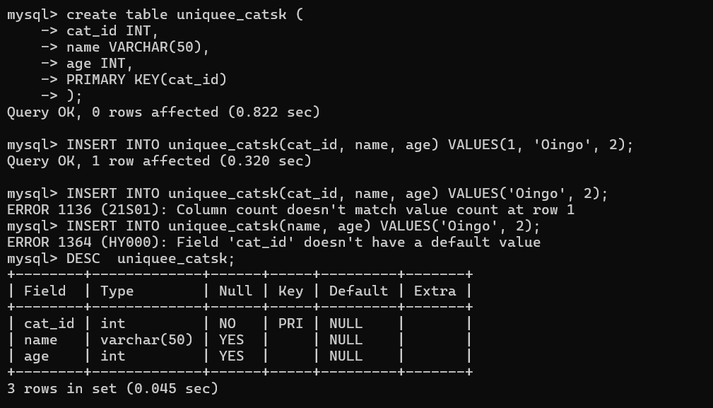

- Auto Increment

Auto Increment used to create a number automatically in primary key values.

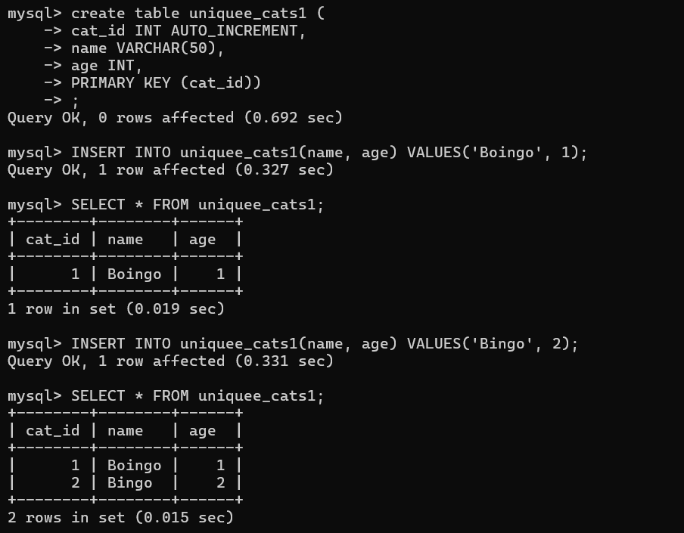

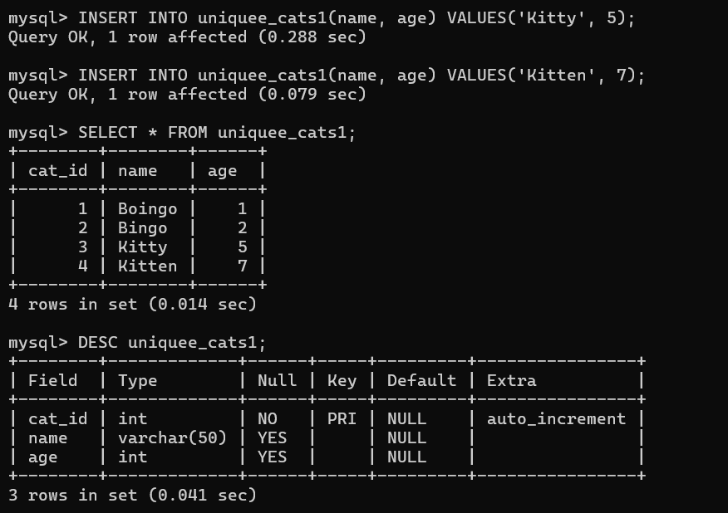

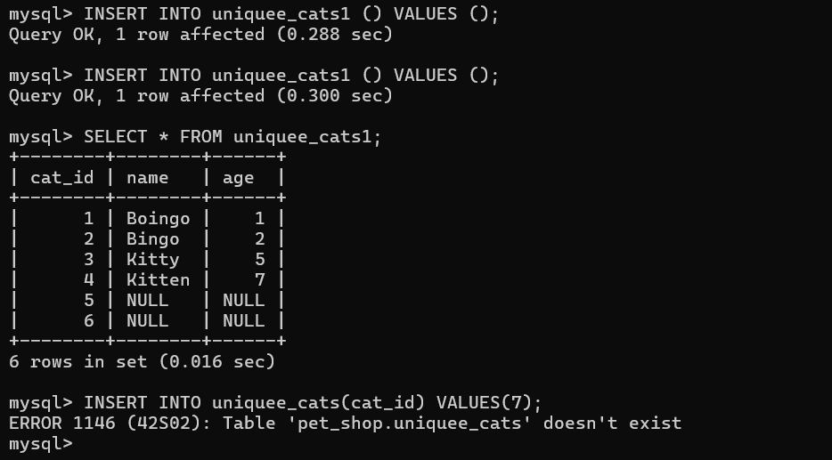

- Exercise

